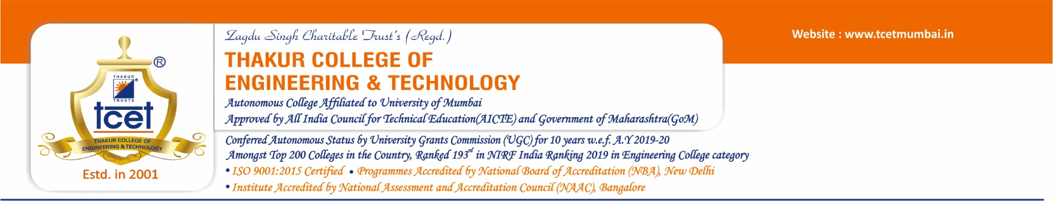
MP/A/04/08
Ref. No.: TCET/EXAM/ of 2023.

EXAM NOTICE No. 01/2023
Date: 03/01/2023

To:
B. E. & M. E. May - 2022 Pass Out Students (All Branches).

Subject: Checking/Correcting the data, specifically name in English, Marathi (Devnagari Script) and CGPI.

All the students who have passed the final year (B. E. & M. E.) examinations held in May 2022 are here by requested to check the data, specifically name in English, Marathi (Devnagari Script) and CGPI to avoid the mistakes in Convocation Degree Certificates.

The above data is available on www.tcetmumbai.in Examination Convocation Data May 2022.

If there is any mistake or discrepancy found, you are required to submit correct information on the link : https://forms.gle/iXr7xXmMNUYpG9CL6 on or before 14/01/2023.

Important Note:

      - It is required to check all semesters’ SGPI which is printed on semester VIII grade card for calculating CGPI to avoid the mistake in Convocation Degree Certificate.
      - If there is no response from your side, the information mentioned in the attached file will be assumed to be correct.
      - The response received after the last date shall not be accepted under any circumstances.

Sd/-
(Dr. B. K. Mishra)
Principal

COPY TO: VICE PRINCIPAL / ALL DEANS / ALL HODS / ALL SECTION INCHARGES / ACCOUNT / WEBSITE UPLOADING

